**Assignment 1**

**. Coding Assignments**

**Hello World Program: Write a Java program that prints "Hello World!!" to the console**

**Output:**

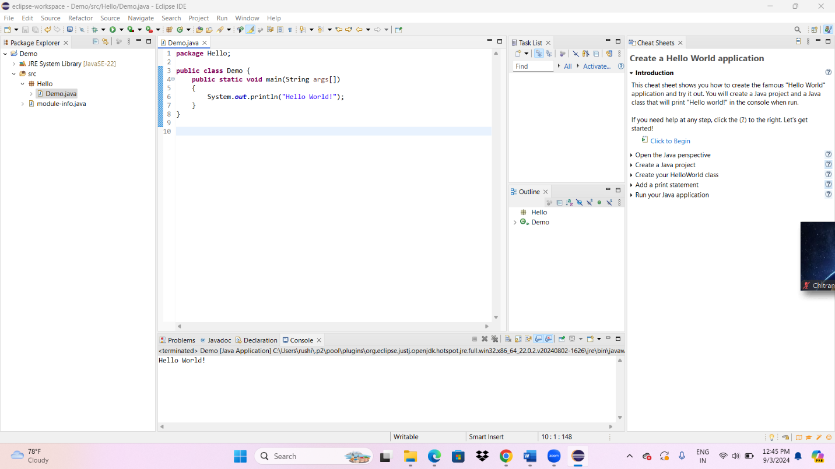

**Code:**

**package Hello;**

**public class Demo {**

**public static void main(String args[])**

**{**

**System.*out*.println("Hello World!");**

**}**

**}**

**Output: Hello World!**